# Section 4.6: Limits at Infinity and Asymptotes

## Limits at Infinity

In this section, we focus on the behavior of a function at the extreme values of $x$ and look at horizontal asymptotes.

### Limits at Infinity and Horizontal Asymptotes

Recall that $\lim_{x→a}{f(x)}=L$ means $f(x)$ becomes arbitrarily close to $L$ as $x$ gets closer to $a$. We extend this idea to limits at infinity. For example, in the graph below, as $x$ gets larger (moving to the right in the graph), the values of $f(x)$ get closer to $2$. We say the limit as $x$ approaches $∞$ of $f(x)$ is $2$ and write $\lim_{x→∞}{f\left(x\right)}=2$.

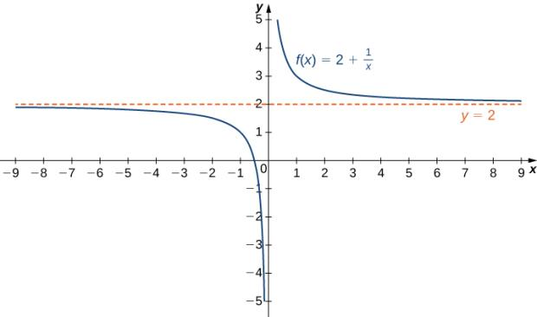

Similarly, as $x$ gets smaller (moving to the left in the graph), the values of $f(x)$ get closer to $2$. We say the limit as $x$ approaches $-∞$ of $f(x)$ is $2$ and write $\lim_{x→-∞}{f\left(x\right)}=2$.

If the values of $f(x)$ become arbitrarily close to $L$ as $x$ becomes sufficiently large, the function $f$ has a limit at infinity, written

$\lim_{x→∞}{f(x)}=L$.

If the values of $f(x)$ become arbitrarily close to $L$ for $x<0$ as $\left|x\right|$ becomes sufficiently large, the function $f$ has a limit at negative infinity, written

$\lim_{x→-∞}{f(x)}=L$.

If $\lim_{x→∞}{f(x)}=L$ or $\lim_{x→-∞}{f(x)}=L$, the line $y=L$ is a **horizontal asymptote** of $f$.

Media: Watch these [video](https://youtu.be/Z5R8KZJ73UI)1 and [video2](https://youtu.be/k-O6lUN6YG0) examples on limits at infinity and horizontal asymptotes.

Examples:

1. For the graph below, identify where the vertical and horizontal asymptotes are located.

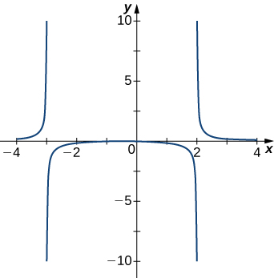

1. For each of the following functions $f$, evaluate $\lim_{x→∞}{f(x)}$ and $\lim_{x→-∞}{f(x)}$. Determine the horizontal asymptote(s) for $f$.

$f\left(x\right)=5-\frac{2}{x^{2}}$

$f\left(x\right)=\frac{\sin{x}}{x}$

$f\left(x\right)=\tan^{-1}(x)$

### Infinite Limits at Infinity

Sometimes the values of a function $f$ become arbitrarily large as $x→∞$ (or as $x→-∞$). In this case, we write $\lim_{x→∞}{f(x)}=∞$ (or $\lim_{x→-∞}{f(x)}=∞$). If the values of a function $f$ are negative but become arbitrarily large in magnitude as $x→∞$ (or as $x→-∞$), we write $\lim_{x→∞}{f(x)}=-∞$ (or $\lim_{x→-∞}{f(x)}=-∞$).

For example, in the graph below of the function $f\left(x\right)=x^{3}$, as $x→∞$, the values of $f(x)$ become arbitrarily large. Therefore, $\lim_{x→∞}{x^{3}}=∞$.

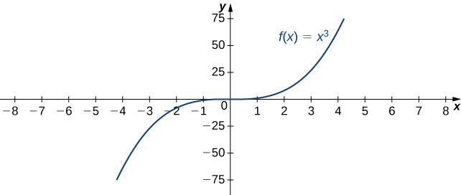

As $x→-∞$, the values of $f(x)$ are negative but arbitrarily large. Therefore, $\lim_{x→-∞}{x^{3}}=-∞$.

A function $f$ has an **infinite limit at infinity** and write

$\lim_{x→∞}{f(x)}=∞$,

if $f(x)$ becomes arbitrarily large for $x$ sufficiently large.

Aa function has a negative infinite limit at infinity and write

$\lim_{x→-∞}{f(x)}=-∞$,

if $f\left(x\right)<0$ and $\left|f(x)\right|$ becomes arbitrarily large for $x$ sufficiently large.

Similarly, we can define infinite limits as $x→-∞$.

Media: Watch this [video](https://youtu.be/WQNi7hre8u0) example on infinite limits at infinity.

Example: Evaluate $\lim_{x→-∞}{\frac{x^{2}-2x+5}{x+2}}$.

## End Behavior

The behavior of a function as $x→±∞$ is called the function’s **end behavior**. At each of the function’s ends, the function could exhibit one of the following types of behavior:

1. The function $f(x)$ approaches a horizontal asymptote $y=L$. Many rational functions have a horizontal asymptote.

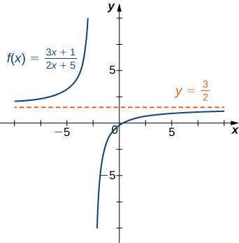

1. The function $f(x)→∞$ or $f\left(x\right)→-∞$. Many power functions have this type of behavior.

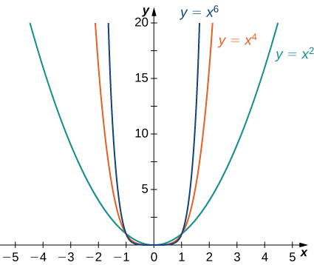

1. The function does not approach a finite limit, nor does it approach $∞$ or $-∞$. In this case, the function may have some oscillatory behavior. Trigonometric functions, like sine and cosine, typically have this type of behavior.

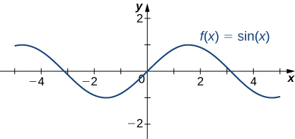

Media: Watch this [video](https://youtu.be/WKwc0sxLRTs) example on asymptotes.

Media: Watch this [video](https://youtu.be/JBOWdxO9iCY?t=104) example on sketching functions with given asymptotes.

Examples

1. Find the horizontal and vertical asymptotes for the function $f\left(x\right)=\frac{1}{x^{3}+x^{2}}$.
2. Construct a function that has the given asymptotes:

$x=1$

$y=2$